Studio 4

Name and Student Id: Xin Xu 30421225

Self-Evaluation:

|  |  |  |  |  |  |
| --- | --- | --- | --- | --- | --- |
| Need Help | Work in Progress | Pass | Credit | Distinction | ***High Distinction*** |

Tutor Evaluation:

|  |  |  |  |  |  |
| --- | --- | --- | --- | --- | --- |
| Incomplete | Needs improvement | Pass | Credit | Distinction | High Distinction |

Task 4.1:

{Answers}

I have done this task

{Screenshots}

A screenshot of Model First

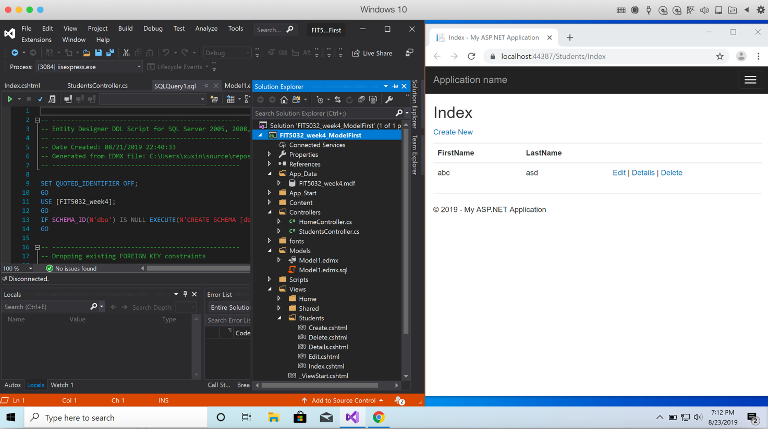

{Link to code repository}

{References}

{URLs}

https://drive.google.com/drive/u/1/folders/1EJm0eM0xhxAZXouHovffv0YsfZgxz1be

Task 4.2:

{Answers}

I have done this task

{Screenshots}

A screenshot of Code First

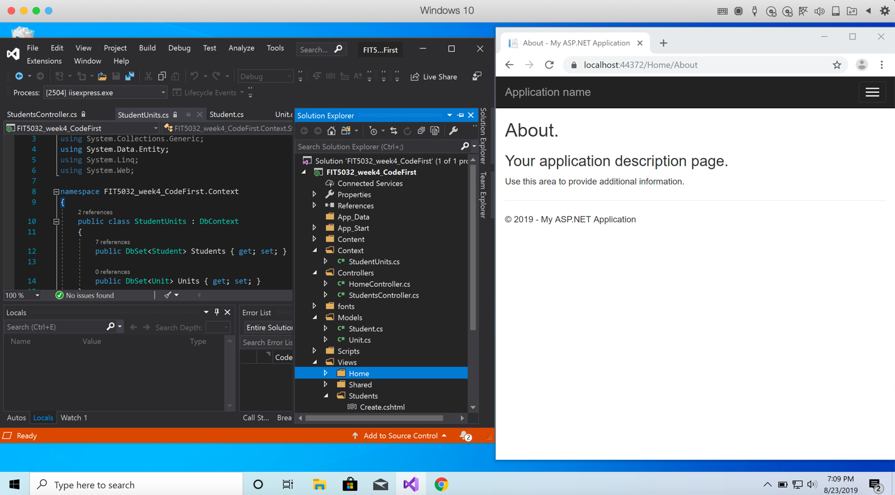

{Link to code repository}

{References}

{URLs}